Estimating U.S. Prescription Drug Rebates Using NADAC and Public Pricing Data, 2013–2022
Ron Balaban, May 2025

This study explores whether publicly available pricing data can be used to estimate pharmaceutical drug rebates in the U.S. from 2013 to 2022. I compiled a list of 200 commonly prescribed drugs, including brand and generic names and their National Drug Codes (NDCs), and gathered annual average prices using the National Average Drug Acquisition Cost (NADAC). These were compared to other metrics such as Wholesale Acquisition Cost (WAC) and Average Wholesale Price (AWP) to examine pricing trends.

Because rebate amounts are confidential and vary by payer and drug, I used estimates from prior studies to approximate average rebate levels. By aligning NADAC with benchmark data, this analysis provides a proxy for understanding rebate behavior and drug pricing dynamics. While NADAC alone cannot reveal exact rebates, combining it with other public data offers a useful method for estimating trends in an otherwise confusing pricing system.
__________________________________________________________________________________________

Within the world of pharmaceutical drugs, multiple entities are involved at different steps of the process, starting with the drug company that researches and develops a drug. The company sets an initial price for the drug, called the list price, to determine how much someone will pay to purchase the drug from a pharmacy. A pharmacy itself also acts as another entity, as it fills a prescription for another entity, the patient. These are the first and last entities within the process of drugs going from creation to receival at the hands of patients, but drug companies also work with other entities such as insurance companies, wholesale distributors, and Pharmacy Benefits Managers (PBM’s). PBMs were introduced in the 1960s to help manage prescription drug benefits. Wholesale distributors package drugs created by the drug manufacturers and ship them to retail pharmacies nationwide.
PBM’s help insurers manage the administration of prescription drug claims, and function as intermediaries between insurance companies and drug companies. They do so by creating formularies, which are proprietary lists of prescription drugs that health insurers will cover and financially reimburse to the drug company. They judge whether drugs are eligible based on safety, quality, and effectiveness. Each PBM will develop different formularies for different insurance and drug companies, with a contract approval process that involves negotiating reimbursement prices, as well as which drugs get included on the formulary. The Center for Medicare and Medicaid Services (CMS) specifies two main requirements for formularies. First, every formulary must include two drugs per therapeutic class. Second, every plan must cover all drugs in six protected therapeutic classes (anticonvulsants, antidepressants, antineoplastics, antipsychotics, antiretrovirals, and immunosuppressants). Beyond these two rules, plans have substantial freedom to design their formularies ⁽¹³⁾.

Typically, health insurance companies offer preferred treatment for brand-name drugs, which are drugs that are sold under a specific patent-protected name or trademark. This preferred status, along with the general name recognition, is what incentivizes patients to use brand-name drugs over generic drugs, which are identical to brand-name drugs in terms of dosage form, safety, strength, route of administration, quality, and performance characteristics. When a patient fills a prescription for a drug that is included on a formulary, the drug company pays some negotiated dollar amount, called a rebate, to the PBM. As a result, the actual price the PBM pays for the drug is the list price minus the rebate value. The PBM then pays some portion of the rebate amount to the insurance company, depending on the clauses agreed upon in the signed contract, and then it allocates those dollar amounts to the plan beneficiaries to lower the costs of insurance and premiums. One important note to clarify is that rebates don’t directly lower the price that patients pay to have their prescriptions filled, as they pay based on the drug’s list price. List prices are set by drug manufacturers and don’t reflect rebates paid and discounts given, which reduce the net price the manufacturer ultimately receives for the sale of its drugs ⁽⁶⁾. The rebate amount simply helps incentivize drug companies to continue creating prescription drugs, in exchange for having their drug be given preferential placement on the formulary.

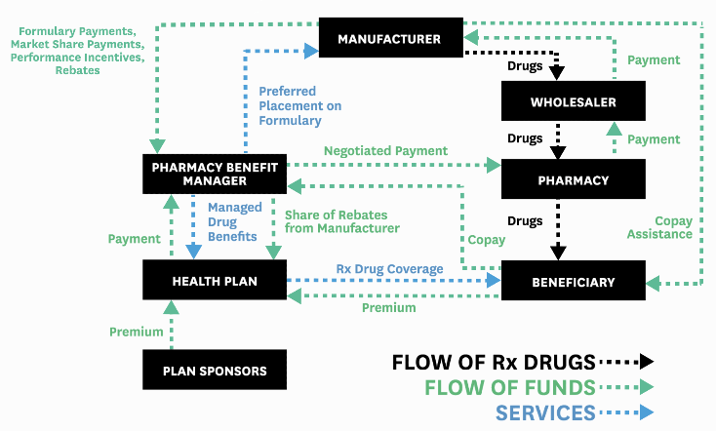
As there are several entities involved along the many steps of the process, each entity is taking some dollar margin for themselves. Additionally, formularies contain up to 4 tiers of drugs, with Tier 1 being devoted to generic drugs, which receive the lowest copay, and Tier 2 being the preferred brand-name drugs, which receive a medium copay. Tier 3 is for non-preferred brand-name drugs, which receive a higher copay, while Tier 4 is reserved for specialty drugs, which receive the highest copay. Specialty drugs are those that treat complex and rare conditions and diseases, and they require special handling, storage, administration, and patient monitoring. Specialty drugs are most notably different than generic drugs and non-specialty brand-name drugs in that they are very expensive, and often the only drug of their kind to treat certain conditions. Currently, there is no statutory, regulatory, or universally industry accepted definition of the term “specialty drugs,” nor a uniform list of “specialty drugs” utilized within state Medicaid programs ⁽¹²⁾. Some health plans could only have 2 or 3 tiers in the formulary, while others have more, but they function identically- drugs in lower tiers cost less, and the higher ones cost more. Drug manufacturers want their drugs placed in Tiers 1 and 2, as they’re the most easily accessible to patients and thus get more sales. Therefore, the drug manufacturer provides the rebate to the PBM to make the drug cheaper for the insurance plan and incentivize the PBM to include it in Tier 1 or Tier 2 in the formulary. Drug manufacturers are willing to pay larger rebates to have their branded drugs placed on the preferred tier of the formulary ⁽¹³⁾.

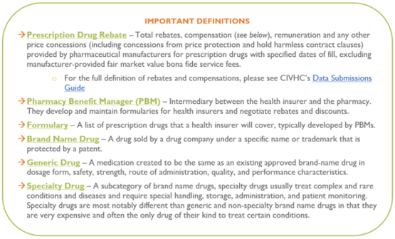
Each PBM will have its own confidential non-disclosable formulary, which they negotiate with the drug manufacturers. PBMs will often structure their contracts to allow them to collect and keep rebates as part of an ‘administrative fee’ or ‘rebate sharing’ arrangement with the health plan instead of passing the rebate to its rightful owner - the purchaser of the medication. PBM’s serve as a third party that complicate the exchange of drugs within the American healthcare system and are the ones responsible for reimbursing the pharmacy for dispensing the patient’s medication. The pharmacy, which has already incurred a cost for stocking and dispensing the medication, has no control over any aspect of the medication’s sale. It is the PBM that determines the patient’s copay and the PBM who determines in advance how much it will reimburse pharmacies for each medication covered under the drug plan. It is the PBM’s that determine how much each drug covered under the plan should cost, and this is the amount it reimburses all pharmacies but the ones it owns. Often, the reimbursement rates are well below the cost of the drug, putting pharmacies in the position of having to fill a prescription at a loss. No one is sure how the cost for each covered drug is determined because PBM’s are not regulated and not required to disclose their formulas for determining cost. PBMs consider this information a “trade secret”, leaving pharmacies with no choice but to appeal losses they incur in order to fill the prescription. Often those appeals are denied or simply ignored by the PBM - despite laws in New York State requiring very specific appeal procedures. Because pharmacies are dependent on having patients, and most patients depend on having a prescription drug plan to help offset the cost of expensive medications, pharmacies are left in a “take it or leave it” situation, business-wise ⁽⁷⁾ .
__________________________________________________________________________________________
Research Merit
My research paper delved into determining how successful certain drugs are within the realm of pharmaceutical rebates, which involved comparing similar drugs and their rebate eligibility/value. My goal was to obtain comprehensive information on drugs and their variations, check the behavior of their prices, and estimate a rebate value based on that data. My initial hypothesis was that brand-name drugs receive higher rebate value depending on how profitable the drug is, rather than how useful it is to patients’ health. This, in turn, leads to drug manufacturers raising list prices for drugs and PBM’s to favor these highly priced or specialty drugs. As there is a lot of contention and discussion revolving around why prescription drugs have gotten more expensive over time, it has become clear that PBM’s actively play a role in that increase. There is a near one-to-one relationship between rising rebates and rising list prices for branded prescription drugs ⁽⁶⁾. Given that the current Trump administration is actively revising how Medicare and Healthcare affect millions of patients nationwide, this analysis is crucial. This paper led to obtaining insights into how specific drug prices changed over time, allowing for transparent, informed policy and decision-making to be based on minimizing costs for patients.

Because there is an enormous quantity of pharmaceutical drugs, I must provide some clarification on the different classifications within the American Medicare/Medicaid System. Medicare can be classified into 2 parts- Part B and Part D. Medicare Part B and Medicare Part D cover outpatient drugs differently, but the simplest explanation is that drugs considered to be Part B are those that need to be administered by a medical provider, such as a flu shot or insulin injection. Part B also covers a limited number of prescriptions from the pharmacy, mainly specialty oral anti-cancer drugs. Drugs covered under Part D are those that a patient can generally administer by themselves. Most outpatient prescription drugs that one can get from a pharmacy are covered under Part D and are thus eligible for rebate if they’re on a patient’s plan’s formulary. Some drugs may be covered by either Part B or Part D. For example, if a patient uses an insulin pump, they probably get their insulin and pump from a durable medical equipment supplier, and Part B would cover it. If a patient injects Insulin via a needle instead, it’ll go under Part D instead. The Inflation Reduction Act (IRA) requires manufacturers to pay rebates to Medicare if they raise their prices for certain Medicare Part B and D drugs faster than the rate of inflation.

There are also limits on how many drugs can be submitted to an insurance company for rebate within a time period. The size of the rebate is rarely disclosed to private insurers or the public. Under current market conditions, PBMs often can retain 10% to 15% of the rebate as profit while passing the remainder on to the insurer, which indicates that a higher list price might generate more revenue for PBMs ⁽¹⁾. Additionally, drug rebates and list prices are positively correlated: On average, a $1 increase in rebates is associated with a $1.17 increase in list price ⁽²⁾, with a 95% confidence interval is [$0.69, $1.66]. This linear regression model accounted for differences in Medicaid drugs based on whether a drug was single-source or multi-source. This study was a joint effort between the USC Leonard Schaeffer Institute for Public Policy & Government Service and SSR Health’s Rx Brand Pricing Data Tool. This pricing tool used to be publicly available and contained quarterly U.S. list prices and estimated U.S. net prices of brand drugs, compiled from product-level net revenues reported by publicly traded pharmaceutical firms in financial statements and earnings calls, and product-level unit volumes from third-party data vendors. However, this pricing tool is now locked behind a $72,000 annual subscription, which is infeasible for my analysis. This tool, no longer publicly viewable, does not provide insight into which metric for ‘List Price’ was used. As expected, drugs with less competition/substitutes generally receive higher rebate rates. I have included the intervals from the study below as a benchmark. Given the general unavailability and inconsistency of which financial metric that other studies use to estimate rebates, I had to explore other approaches.
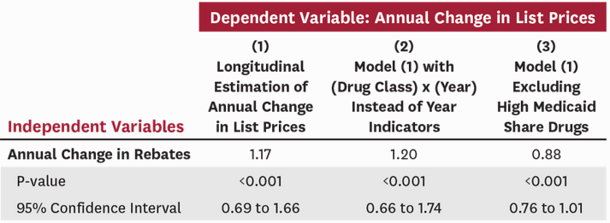
__________________________________________________________________________________________
Potential Drug Financial Metrics for Estimating Rebates

National Average Drug Acquisition Cost (NADAC)
NADAC was jointly developed by the Centers for Medicare and Medicaid Services (CMS), and it calculates the average price that pharmacies pay for prescription drugs. This average price value is used as a standard for the supply and demand of prescription drugs, and it involves the use of invoice prices paid by retailers. NADAC provides more transparency and insight into drug spending and pricing, making it the obvious choice for PBM contracts ⁽¹⁰⁾

Whole-Sale Acquisition Cost (WAC)
WAC represents the manufacturer's published catalog or list price for a drug product to wholesalers as reported to First Databank by the manufacturer. The term “manufacturer” in this context includes repackagers, private labelers, and other suppliers. WAC does not represent actual transaction prices and does not include discounts, rebates, or other reductions in price ⁽³⁾. WAC excels when assessed by best benchmark criteria for accessibility, administrative simplicity, and low administrative cost. WAC is closer to AAC (Actual Acquisition Cost) than AWP, and as the basis for AWP, it is more transparent ⁽¹⁵⁾.

Average Wholesale Price (AWP)
AWP is a pharmaceutical term that describes the average price paid by a retailer to buy a drug from the wholesaler. AWP has often been compared to the “list price” or “sticker price”, meaning it is an elevated drug price that is rarely what is actually paid. AWP is not a government-regulated figure, does not include buyer volume discounts or rebates often involved in prescription drug sales, and is subject to manipulation by manufacturers or even wholesalers. As such, the AWP, while used throughout the industry, is a controversial pricing benchmark ⁽¹¹⁾. Because the AWP is part of the reimbursement formula used in Medicare Part B and by many state Medicaid programs, any increase in the published AWP can increase the billions of dollars that federal and state governments pay for prescription drugs ⁽¹⁷⁾.

Annual Manufacturer Price (ANMP)
The Medicare Prescription Drug Inflation Rebate Program requires ANMP for Medicare Part D and Average Sales Price (ASP), WAC (Wholesale Acquisition Cost), or maximum fair price for Medicare Part B ⁽³⁾ . It is a pricing metric used to calculate inflation rebates, and it reflects the average price paid by wholesalers for drugs distributed to retail pharmacies and is often substituted in profit reporting over ASP or WAC. The AMP is not a published price. It is calculated by the manufacturer and submitted to CMS for purposes of calculating the Medicaid rebate. The government holds it confidentially to protect the proprietary nature of the deals negotiated between manufacturers and their best customers ⁽¹⁷⁾.

__________________________________________________________________________________________
Data Acquisition & Analysis Methodology

Finding datasets that actually contain rebate-level information provided to be very tricky, as pharmaceutical companies keep their rebate amounts as proprietary information. My approach involved initially scraping a list of drug names, along with their brand name and generic name substitutes. Because the time frame for this project was limited to 3 months, I also limited my analysis to the 200 most prescribed drugs from 2013-2022. My initial data was scraped from the ClinCalc Drug Stats Database ⁽¹¹⁾, which in turn was sourced from the Medical Expenditure Panel Survey (MEPS) for 2013-2022, conducted by the Agency for Healthcare Research and Quality (AHRQ). I stored all obtained data within R dataframes. Besides obtaining the names for the drugs, I also obtained the total prescriptions, total patients, along with the following 4 cost-related fields:
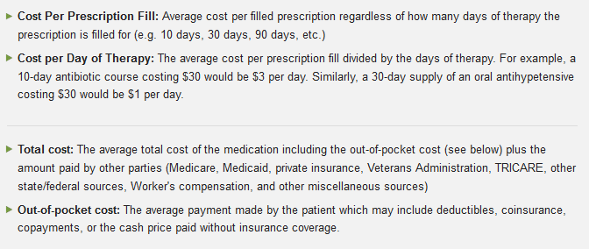
This data has a lag of 2 years, so the MEPS 2022 database was released in August 2024. Per the ClinCalc’s own sourcing methodology: In order for the ClinCalc Drug Stats database to implement the MEPS data, basic data sanitization and standardization measures are required: (1) Sanitization measures include identifying prescriptions that are not valid medications or those with incomplete data. As an example, there are entries within MEPS that do not include an actual medication name or only describe the medication class. Because these entries cannot be used to aggregate prescription utilization data, these entries are removed. (2) Standardization measures are used to aggregate like medications so that they are "counted" as the same active ingredient. For example, "Vicodin", "hydrocodone/APAP", "hydrocodone / acetaminophen", and "APAP/hydrocodone" are all the same active ingredients but are treated as distinct entities in the MEPS database. Using the FDA National Drug Code (NDC), the FDA Orange Book, and the NLM RxNorm databases, all ClinCalc Drug Stats entries must be standardized against known chemical entities. This process of sanitization and standardization results in a slight reduction of prescription data (less than 1%) but dramatically improves the accuracy and reliability of the resulting dataset ⁽⁵⁾.

The ClinCalc website provides the top 200 drugs, which represent 95% of all prescriptions for 2013-2022. While before I had considered some form of classification or clustering based on which drugs are rebateable, that information is confidential and proprietary for PBM’s, so I assumed that every single reported drug is rebateable for some unknown amount. The data is aggregated at an annual level, so I will likely not observe any seasonality, but there could be cyclical behavior for some drugs. However, from all other academic papers on the same subject, it seems that a majority of drugs experience constant growth. One other thing to keep in mind is the possibility of drug name collision/duplication, which occurs when different drugs contain the same brand/generic/ingredient names. For example, ‘Fluticasone’ vs ‘Fluticasone; Salmeterol’, or ‘Metformin’ vs ‘Metformin; Sitagliptin’. By highlighting which drugs could be nested within one another, or be a sub-product of each other, it allowed for my analysis to aggregate the specific data for one drug within the umbrella of another drug. However, I opted to preserve the granularity of each drug, even if there was some potential overlap.

I obtained the National Drug Code (NDC) from the U.S. Food and Drug Administration NDC Directory ⁽⁸⁾, which contains product listing data submitted for all finished drugs, including prescription and over-the-counter drugs, approved and unapproved drugs, and repackaged and relabeled drugs. I did this by creating two functions to parse through the Proprietary Name, Non-Proprietary Name, and Substance Names of every single NDC within the FDA’s dataset. The former would return partial matches, such as finding "atorvastatin" in those fields, as a result for the drug "amlodipine and atorvastatin". This approach was quicker but riskier, as if I didn’t provide all possible brand names for a drug, it could miss correct NDC’s and was chosen for drugs where I had the exact search term, “Atorvastatin Calcium” for example. The second approach was to create drug-specific lists of names to match against all 3 name fields, where it could return partial matches by using all associated brand/generic drug names for smarter matching. This created structured, systematic lookup tables that had great accuracy and returned all associated NDC’s, albeit more slowly. The figure below visualizes the difference in NDC matches for 36 drugs that received a mismatch in direct and fuzzy drug-name matches
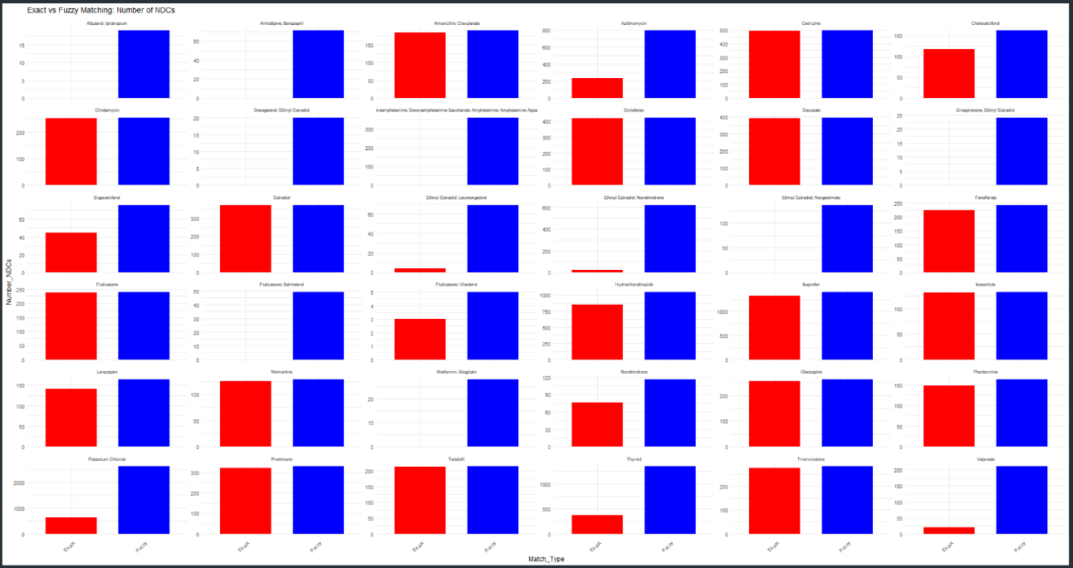
As shown above in blue, fuzzy matches proved to be overly flexible for several drugs, with the most extreme example being Potassium Chloride, which received 627 exact matches and 2,612 fuzzy matches. For the drugs that already received a suitable quantity of exact matches, I chose to opt out of the fuzzy approach. The functions were run against the data, at which point it revealed that there was a small handful of drugs that received 0 NDC hits. I opted to manually adjust the NDC’s for these drugs after searching through the U.S. FDA Directory’s file to ensure optimal accuracy.

Once the computations had finished, a list of originally 200 drugs had expanded to a collection of over 40,000 NDC’s. Specialty drugs, as expected, contained very low quantities of NDC’s, such as ‘Fluticasone; Umeclidinium; Vilanterol’, also sold as ‘Trelegy Ellipta’, which is a fixed-dose combination inhaled medication that is used for the maintenance treatment of chronic obstructive pulmonary disease (COPD). The drug with the largest number of fuzzy NDC hits was ‘Acetaminophen’, which is sold under the brand names ‘Acephen, Infants' Feverall, Injectapap, Neopap, Ofirmev, Tylenol’, with 3403 NDC’s containing any of those key words within the Proprietary Name, Non-Proprietary Name, and Substance Names of the FDA dataset.

The next step was to zone in on the proper 11-digit CMS of each of those NDC’s. Each NDC actually contains the 5-digit Labeler code, 4-digit Product Code, and 2-digit Package Code. Package size is included as an additional delineation when there is a demonstrated variation in acquisition prices between package sizes for drugs in which the most cost-effective package size cannot be purchased and easily repackaged for dispensing (e.g., topical creams and ointments) ⁽¹²⁾. For example, the standard NDC 0002-1433 for the drug ‘Dulaglutide’, has 2 different package codes: 2 Syringe in 1 Carton / .5 mL in 1 Syringe (0002-1433-61); and 4 Syringe in 1 Carton / .5 mL in 1 Syringe (0002-1433-80). This further granularity expanded my list of 40,00 standard NDC’s to over 93,000 CMS-standard NDC’s. With the CMS NDC’s obtained, I needed to find some price metric.

There are different approaches for considering the list price of a drug, such as how the Assistant Secretary For Planning and Evaluation (ASPE)’s Office of Health Policy tackled their analysis. In their study – “Changes in the List Prices of Prescription Drugs, 2017-2023”, researchers state - “For this analysis, we used the WAC (Wholesale Acquisition Cost) as the price for a given product at the package size level. WAC, as published by First Databank and available through AnalySource, represents the manufacturer's published catalog or list price for a drug product to wholesalers as reported to First Databank by the manufacturer” ⁽³⁾. As there is limited, if any, public information disclosing manufacturers’ published WAC’s or AWP’s, I opted to use NADAC as my baseline price metric. NADAC is designed to create a national benchmark that is reflective of the prices paid by retail community pharmacies to acquire prescription and over-the-counter covered outpatient drugs. Numerous data sources are relied upon in order to facilitate the collection, calculation, analysis, and reporting of the NADAC ⁽¹²⁾, including:
- Drug acquisition cost data collected through voluntary monthly surveys of retail community pharmacy entities (independent and chain pharmacies).
- A national pharmacy file used to identify individual pharmacies.
- Drug identification and published pricing information obtained from national drug compendia files.
- The most recently available covered outpatient drug product file from CMS’ Medicaid website, Medicaid.gov, for use in NADAC criteria evaluation. In addition, interim updates, when available, are received from CMS for newly available covered outpatient drugs.

By using CMS’ website, Data.Medicaid.gov, I was able to find the ‘NADAC Comparison’ dataset. This comprehensive resource contained crucial fields, such as the NDC Description, 11-digit standard CMS NDC, Old and New NADAC per Unit, along with the Start Date, End Date, and Effective Dates for nearly 3 million NDC’s. Using CMS’ API documentation, I created batch jobs to extract every NADAC value for my 93,000 CMS NDC’s, averaged the price results on an annual basis, and filtered the data to the years 2013-2022. Due to the large number of NDC’s that needed to be called, and that each year could have anywhere from a dozen to over a hundred NADAC values for each NDC, followed by the annual averaging process, the entire API call took over 27 hours to complete. Once the API calls had run, I joined the combined data with my package-level NDC data, along with ClinCalc data, to create a dataframe with these fields:
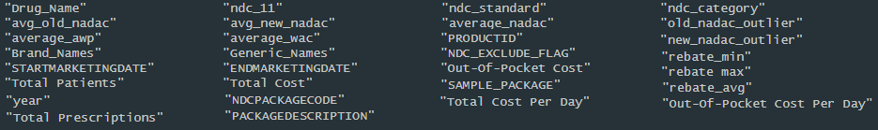

As I had acquired the NADAC for all of my CMS NDC’s for the 200 selected drugs, the next step was to find a relationship between a rebate percentage and NADAC, but no such relationship currently exists. CMS allows States flexibility to define estimated acquisition cost; most States base their calculations on AWP or WAC ⁽¹⁶⁾. However, based on median studies performed to find relationships between NADAC and AWP, AWP is typically an inflated benchmark that is 3x to 10x higher than NADAC for Generic Drugs, and 1.2x to 1.5x higher for Brand Drugs. I modified the function I used to scrape NDC’s for drugs and identified if a CMS NDC belonged to a generic or brand name. I then used the average AWP:NADAC ratio of 6.5:1 for brand, and 1.35:1 for generic drugs to create average values for AWP for each of 11-digit CMS NDC’s. With average estimates for AWP, I was able to create an average WAC value based on studies done on the WAC:AWP ratio of 1:1.25 before March 2009, and 1:1.20 afterwards ⁽¹⁸⁾, the latter of which was applicable given my data ranged from 2013-2022. Unlike AWP, WAC is defined in federal statute - “the manufacturer’s list price for the drug or biological to wholesalers or direct purchasers in the United States, not including prompt pay or other discounts, rebates or reductions in price ⁽¹⁵⁾. Using the aforementioned rebate ranges set by USC Leonard Schaeffer Institute and the SSR Health’s Rx Brand Pricing Data Tool, I created minimum, average, and maximum estimates for rebates using 0.69$, 1.17$, and 1.66$ as a ratio to the Average WAC for each CMS NDC. Finally, I created an interactive Shiny app with all the price metrics and ease-of-access I could think of: NADAC Drug Estimates

Conclusion, Reflections, Challenges, and Suggestions

This study explored whether publicly available data, specifically NADAC pricing, list prices, and drug utilization, could be used to estimate rebates for pharmaceutical drugs from 2013 to 2022. While exact rebate amounts remain confidential, my findings show that most drugs prices are increasing, along with the associated rebate amounts. Estimating rebates is inherently difficult due to the lack of transparency in rebate contracts, which are negotiated privately between manufacturers and PBM’s, and can vary by payer, formulary tier, and drug class. Public data sources like CMS’s utilization datasets help but can’t provide entirely accurate rebate values at the drug or NDC level.

Future research could benefit from incorporating formulary-level data. For example, assigning higher estimated rebates to drugs on preferred tiers and lower rebates to those on non-preferred or specialty tiers. Additional insights could come from analyzing total therapy costs and treatment patterns, rather than focusing only on unit prices. Overall, while NADAC data alone can’t fully reveal rebate amounts, it offers a useful proxy when combined with other contextual information. This approach can help future researchers better understand pricing dynamics in a market where list prices often do not reflect what is actually paid.
__________________________________________________________________________________________
Notes on Prior Research
List Price: From January 2022 to January 2023, price changes ranged from a decrease of 99% to increases of over 3,000% . Over this period, 4,264 drug products had price increases. Of these increases, 1,982 (46%) were greater than the increase in the CPI for all urban consumers. During the same period, 1,599 drug products had price decreases. For those drugs with a price increase, the average increase from January 2022 to January 2023 was 15.2%. This is higher than the average price change between 2021 and 2022 of 11.5%. ⁽³⁾
Rebates to PBMs are likely to account for most of this rising difference, but other contributors include manufacturer payments and discounts to other intermediaries including wholesalers and pharmacies. ⁽²⁾
There were 1,216 products whose price increases during the twelve-month period from July 2021 to July 2022, which exceeded the inflation rate of 8.5% for that time period. The average price increase for these drugs was 31.6% . Some drugs in 2022 increased by more than $20,000 or 500%.” ⁽⁴⁾
From 2007 to 2018, list prices increased by 159% (95% CI, 137%-181%), or 9.1% per year, while net prices increased by 60% (95% CI, 36%-84%), or 4.5% per year, with stable net prices between 2015 and 2018. Discounts increased from 40% to 76% in Medicaid and from 23% to 51% for other payers ⁽¹⁴⁾.
__________________________________________________________________________________________
Prior Research and Citations
- Bai, G., Sen, A. P., & Anderson, G. F. (2018). Pharmacy benefit managers, brand-name drug prices, and patient cost sharing. Annals of Internal Medicine, 168(6), 436–438. https://doi.org/10.7326/M17-2506
- Sood, N., Ribero, R., Ryan, M., & Van Nuys, K. (2020, February 11). The association between drug rebates and list prices. USC Schaeffer Center for Health Policy & Economics. https://schaeffer.usc.edu/research/the-association-between-drug-rebates-and-list-prices/
- Bosworth, A., Sheingold, S., Finegold, K., Sayed, B. A., De Lew, N., & Sommers, B. D. (2023, October 6). Changes in the list prices of prescription drugs, 2017–2023. Office of the Assistant Secretary for Planning and Evaluation (ASPE), U.S. Department of Health & Human Services. https://aspe.hhs.gov/reports/changes-list-prices-prescription-drugs

- Bosworth, A., Sheingold, S., Finegold, K., De Lew, N., & Sommers, B. D. (2022, September 30). Price increases for prescription drugs, 2016–2022. Office of the Assistant Secretary for Planning and Evaluation (ASPE), U.S. Department of Health & Human Services. https://aspe.hhs.gov/reports/prescription-drug-price-increases
- ClinCalc. (n.d.). ClinCalc DrugStats database: Free U.S. outpatient drug usage statistics. Retrieved May 20, 2025, from https://clincalc.com/DrugStats/
- Hedt, S. (2020, February 11). New evidence shows prescription drug rebates play a role in increasing list prices. USC Leonard D. Schaeffer Institute for Public Policy & Government. https://schaeffer.usc.edu/research/new-evidence-shows-prescription-drug-rebates-play-a-role-in-increasing-list-prices/
- Pharmacists Society of New York State. (n.d.). PBM Basics. Retrieved May 20, 2025, from https://www.pssny.org/page/PBMBasics
- U.S. Food and Drug Administration. (n.d.). National Drug Code directory. Retrieved May 20, 2025, from https://www.fda.gov/drugs/drug-approvals-and-databases/national-drug-code-directory
- National Library of Medicine. (n.d.). DailyMed: Drug information. Retrieved May 20, 2025, from https://dailymed.nlm.nih.gov/dailymed/index.cfm
- Centers for Medicare & Medicaid Services. (2024, December 23). National Average Drug Acquisition Cost (NADAC) [Data set]. Medicaid.gov. https://data.medicaid.gov/dataset/99315a95-37ac-4eee-946a-3c523b4c481e
- Anderson, L. A. (2025, April 4). Average wholesale price (AWP) as a pricing benchmark. Drugs.com. https://www.drugs.com/article/average-wholesale-price-awp.html
- Centers for Medicare & Medicaid Services. (2024, December). Methodology for calculating the National Average Drug Acquisition Cost (NADAC) for Medicaid covered outpatient drugs [PDF]. U.S. Department of Health & Human Services. https://www.medicaid.gov/medicaid-chip-program-information/by-topics/prescription-drugs/ful-nadac-downloads/nadacmethodology.pdf
- Olssen, A. L., & Demirer, M. (2019, October 31). Drug rebates and formulary design: Evidence from statins in Medicare Part D. Massachusetts Institute of Technology. https://tinyurl.com/954nzyc6
- Hernandez, I., San-Juan-Rodriguez, A., & Good, C. B. (2020, March 3). Changes in list prices, net prices, and discounts for branded drugs in the US, 2007–2018. JAMA, 323(9), 854–862. https://doi.org/10.1001/jama.2020.0001

- Curtiss, F. R., Lettrich, P., & Fairman, K. A. (2010). What is the price benchmark to replace average wholesale price (AWP)? Journal of Managed Care & Specialty Pharmacy, 16(7), 492–501. https://doi.org/10.18553/jmcp.2010.16.7.492
- Levinson, D. R. (2012, October 16). Analyzing changes to Medicaid federal upper limit amounts (Report No. OEI-03-11-00650). U.S. Department of Health and Human Services, Office of Inspector General. https://oig.hhs.gov/reports/all/2012/analyzing-changes-to-medicaid-federal-upper-limit-amounts/
- Gencarelli, D. M. (2002, June 7). Average wholesale price for prescription drugs: Is there a more appropriate pricing mechanism? (Issue Brief No. 775). National Health Policy Forum. https://www.ncbi.nlm.nih.gov/books/NBK561162/
- SmithRx. (2024, September 12). AWP vs. WAC: What’s the difference? https://www.smithrx.com/blog/awp-vs-wac-whats-the-difference

